Group Name | Commercial Managers Network
Group type | Network
Chair | Carl Fiddimore – CNOOC
Vice Chair | Katy Heidenreich - OGUK
Issue Date | March 2020
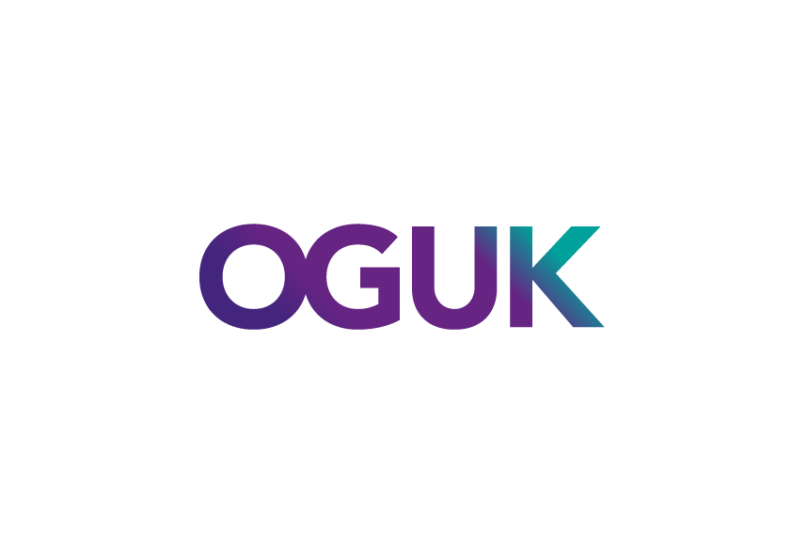
Rationale/Objectives
To provide sustainable leadership for developing and embedding the collaborative and problem solving commercial behaviours needed to efficiently deliver MER UK.
- Act as custodians of CCOP and ICOP, and champions of described behaviours. Measure progress against CCOP & ICOP expectations.
- Owners of specific industry-led commercial work groups
- Provide a forum to share commercial lessons & good practice, to allow discussion of direction of travel on MER UK behaviours and to build connections and trust between Commercial Managers outside of the heat of a negotiation or dispute.
- Vehicle for the OGA and Oil & Gas UK members to engage directly with the leaders of commercial behaviours within each organisation working in UKCS.

The CMF shall operate in a fully transparent, proportionate and non-discriminatory manner and work towards addressing identified commercial issues within the scope described above. It will always operate in accordance with Oil & Gas UK’s governance structure and policies. The collection and/or sharing of any information amongst its members as well as all correspondence and dealings shall be subject to Oil & Gas UK’s Competition Law Compliance Policy. The CMF replaces the “Commercial Code of Practice Champions Network” .

The CMF shall seek to proceed by consensus. Where there is no consensus the matter will be raised to the Oil & Gas UK Board for determination.

Membership

A senior Commercial Manager from every licensee or infrastructure operator member in UKCS. The expectation from the Oil & Gas UK Board is that each company nominates a suitable Manager to participate in the CMF, engages constructively, and steps up to serve on the steering group or individual work groups as required.

One representative for each member should try to attend each meeting. Multiple representations should be avoided unless there is a specific topic of relevance on the agenda. Members may be asked to dedicate time to the work of the CMF (or any of its work groups) from time to time, and this may be during working hours. Oil & Gas UK is grateful for this resource and would not be able to accomplish its aims without it.

Roles and Responsibilities
The CMF is led by a Steering Group representing a cross section of its membership and consists of:
- The CMF Chair & Vice Chair who will lead the work of the Steering Group and the CMF
- Further Steering Group members representing a cross section of CMF membership
- The current Chair of the Oil & Gas UK Operators Legal Committee
- A representative from the Oil & Gas Authority

The Steering Group shall seek to ensure that:
- the CMF accomplishes its objectives by planning workgroup activities and evaluating implementation and progress of work
- any concerns, support requirements, etc. with project delivery are raised with the relevant Oil & Gas UK representative or department
- the CMF is made up of a cross section of industry and has a sufficient level of experience
- any product delivered by the CMF represents a balanced industry viewpoint

The Steering Group is formed of volunteers from the CMF who will typically serve for up to 2 years. The Steering Group will appoint the Chair and Vice Chair for up to 2 years at a time, each with the possibility of re-appointment. The Chair and Vice Chair should not be replaced at the same time. The Steering Group meets on a monthly basis. Meetings will have an agenda that has been circulated in advance, and meeting minutes will be taken and circulated for approval.

As of March 2020 the Steering Group consists of:

- Carl Fiddimore – CNOOC - Chair
- Katy Heidenreich – OGUK Operations Director and – Vice Chair
- Francesca Bell – OGUK
- Tracey Keith – (OGUK – Operators Legal Committee)
- David Hampton – Total
- Gary Hughes – Chrysaor
- John Murphie - INEOS
- Karen MacLennan – BP
- Peter Newton – BP
- Louise Fotheringham – Shell (Cultural Change Representative)
- Simon Churchfield – OGA
- Stuart Hardie – ExxonMobil
- Mark Dryden-Brownlee – NSMP
- Peter Lunny - Neptune
Administrative and organisational support for the CMF and the Steering Group will be provided by Oil & Gas UK, specifically:
- Convening and organising meetings, issuing agenda and pre-read materials
- Taking minutes of meetings, capturing and tracking agreed actions, and communicating these as soon as practicable after the meeting.
- Storing and managing all data and documents associated with the work of the CMF.

The CMF will refer to Oil & Gas UK’s Operations Director for support, linkage within Oil & Gas UK, and assessing all aspects of the organisation’s government and public relations and media services.

Commercial work Groups -

The CMF provides a platform for Commercial Work Groups to be formed to own and work specific work streams, and for progress to be communicated. Work Groups may be ongoing or may exist for a defined period of time to deliver a specific project. Each Work Group will generally be led by a member of the Steering Group & resourced by the broader CMF using the full range of resource available within their respective organisations (including commercial & legal practitioners, subject matter experts, etc.). Each Work Group will publish an activity plan highlighting where support from the broader CMF will likely be needed and will provide monthly updates for endorsement at CMF meetings.

As of March 2020, Commercial Work Groups and leads are as follows:

- Infrastructure – David Hampton
- Case Study Workgroup – Gary Hughes
- Energy Transition – Peter Newton
- After Action Report Workgroup – TBC (Carl Fiddimore as interim)

Meeting Frequency

The full CMF will generally meet for half a day, twice per year. Forums will have an agenda that has been circulated in advance, and meeting minutes will be taken and circulated. Typical discussion topics are likely to include:
- Updates on progress from Commercial Work Groups, identification of support needed from CMF members and their respective organisations, presentation and discussion of forward plans.
- Sharing of key success stories and lessons learned in the context of MER UK.
- Review of status of ICOP/CCOP, including performance data.
- Input to selecting future Work Group topics and seeking volunteers to help deliver these.

The Steering Group will meet the second week of every month, alternating between different steering committee member offices. Minutes will be shared amongst the group via email trail and approved at the following meeting. The Steering Group will also provide periodic email updates to CMF members between meetings.

External Linkages & Reporting

The CMF is led by industry and Oil & Gas UK. It will provide updates to the Oil & Gas UK Board and the Oil & Gas Authority as required. It is acknowledged that there will be overlapping interests with the Oil & Gas UK Operators Legal Committee (OLC) and the CMF will coordinate activity with the OLC as required, including organising joint meetings and communication where this is deemed appropriate.

Note:
All meetings are subject to our Competition Law Compliance Policy - see http://oilandgasuk.co.uk/legalservices.cfm

Oil & Gas UK’s Competition Law Compliance Policy can be found at: http://oilandgasuk.co.uk/legalservices.cfm
A chart of Oil & Gas UK’s Forums and Work Groups can be found at http://oilandgasuk.co.uk/about-us/forums.cfm

